**Prework for DBFW Workshop**

1. **Download DB Sec image from Retriever. This is a .zip file containing a .vdi file that will be used in Virtual Box.**
   1. **The link is:** <ftp://ff-ftp.us.oracle.com/pub/outgoing/idm-security-VMs/barbara.gingrande/DB11g.zip>
   2. **Username / Password for rstetcupload is fusionftp / oracle1**
2. **Download Windows Image from Retriever. This is a .zip file containing a .vdi file that will be used in Virtual Box.**
   1. **The link is:** <ftp://ff-ftp.us.oracle.com/pub/outgoing/idm-security-VMs/barbara.gingrande/WinClient.zip>
3. **Download DBFW Software from eDelivery**
   1. [**https://edelivery.oracle.com**](https://edelivery.oracle.com)
   2. **Pick Language or Continue**
   3. **Export Validation, Continue**
   4. **Oracle Database, Linux x86**
   5. **Scroll to Bottom, Firewall 5.0.0.0 Media Pack**
   6. **Download the last four links:**

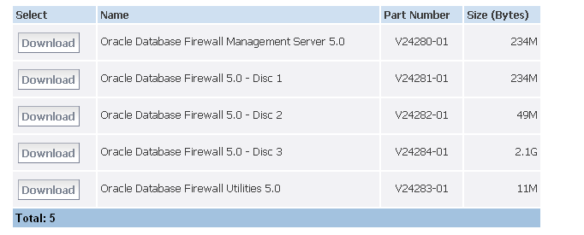



1. **Download OEL5**
   1. **Go to** [**https://edelivery.oracle.com/linux**](https://edelivery.oracle.com/linux)
   2. **Export Validation, etc.**
   3. **Pick Linux, x86 32 bit**
   4. **I used Release 5, Update 5:**



1. **Unzip everything into a folder for ISOs for later mounting in VBox -- (we’re using “multi” – you won’t have “mgmtsvr”)**

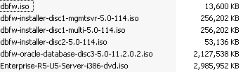

1. **Be sure you’ve installed VirtualBox on your machine and you’ll be ready to go!** [**http://www.virtualbox.org/wiki/Downloads**](http://www.virtualbox.org/wiki/Downloads)